04th November 2016

SEAT LEON Eurocup Title Decider in Barcelona

The International SEAT Leon Eurocup, with the Japanese premium tyre manufacturer YOKOHAMA as exclusive tyre supplier, comes to a spectacular finale in Barcelona this weekend.

An attractive and powerful SEAT Leon car, superb international race tracks, months of hard work, training, testing, team spirit and countless sleepless nights, have all been part of the necessary ingredients that have brought this single make trophy popularity and excitement to date and promises some more drama and unforgettable moments of racing in its final encounter of the season.

Three contenders with a very narrow gap between them are still within reach of the Championship with the Dutchman Niels Langeveld, (Bapporo Motorsport) currently in the lead, closely followed by Stian Paulsen from Norway (Paulsen Racing) and no newcomer to the Circuit Catalunya, from Spain, Mikel Azcona (PCR Sport) in third.

“The Barcelona circuit is a very technical track with many corners and a good long straight which allows overtaking by taking advantage of the slipstream. A fast set-up is required and the action is guaranteed at the weekend’s conclusion of the series”, added David Oliva, Communications Manager for YOKOHAMA Europe. “We would like to wish all competitors and teams the best of luck”, he concluded.

The international series has visited Estoril in Portugal, Silverstone in the UK, Paul Ricard in France, Mugello in Italy, Red Bull Ring in Austria and the legendary Nürburgring in Germany prior to the much awaited final race weekend in Barcelona.

2016 SEAT Leon Eurocup current standings

1. Niels Langeveld (#10), Baporo Motorsport; 202 points
2. Stian Paulsen (#34), Stian Paulsen Racing; 191 points
3. Mikel Azcona (#1), PCR Sport; 185 points

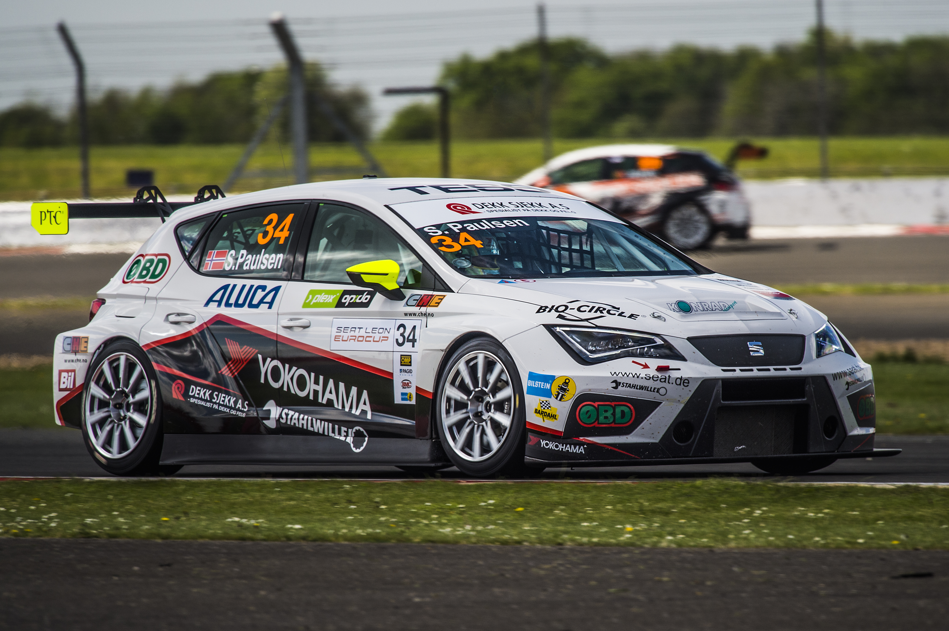
Paulsen wins Race 2 at Silverstone

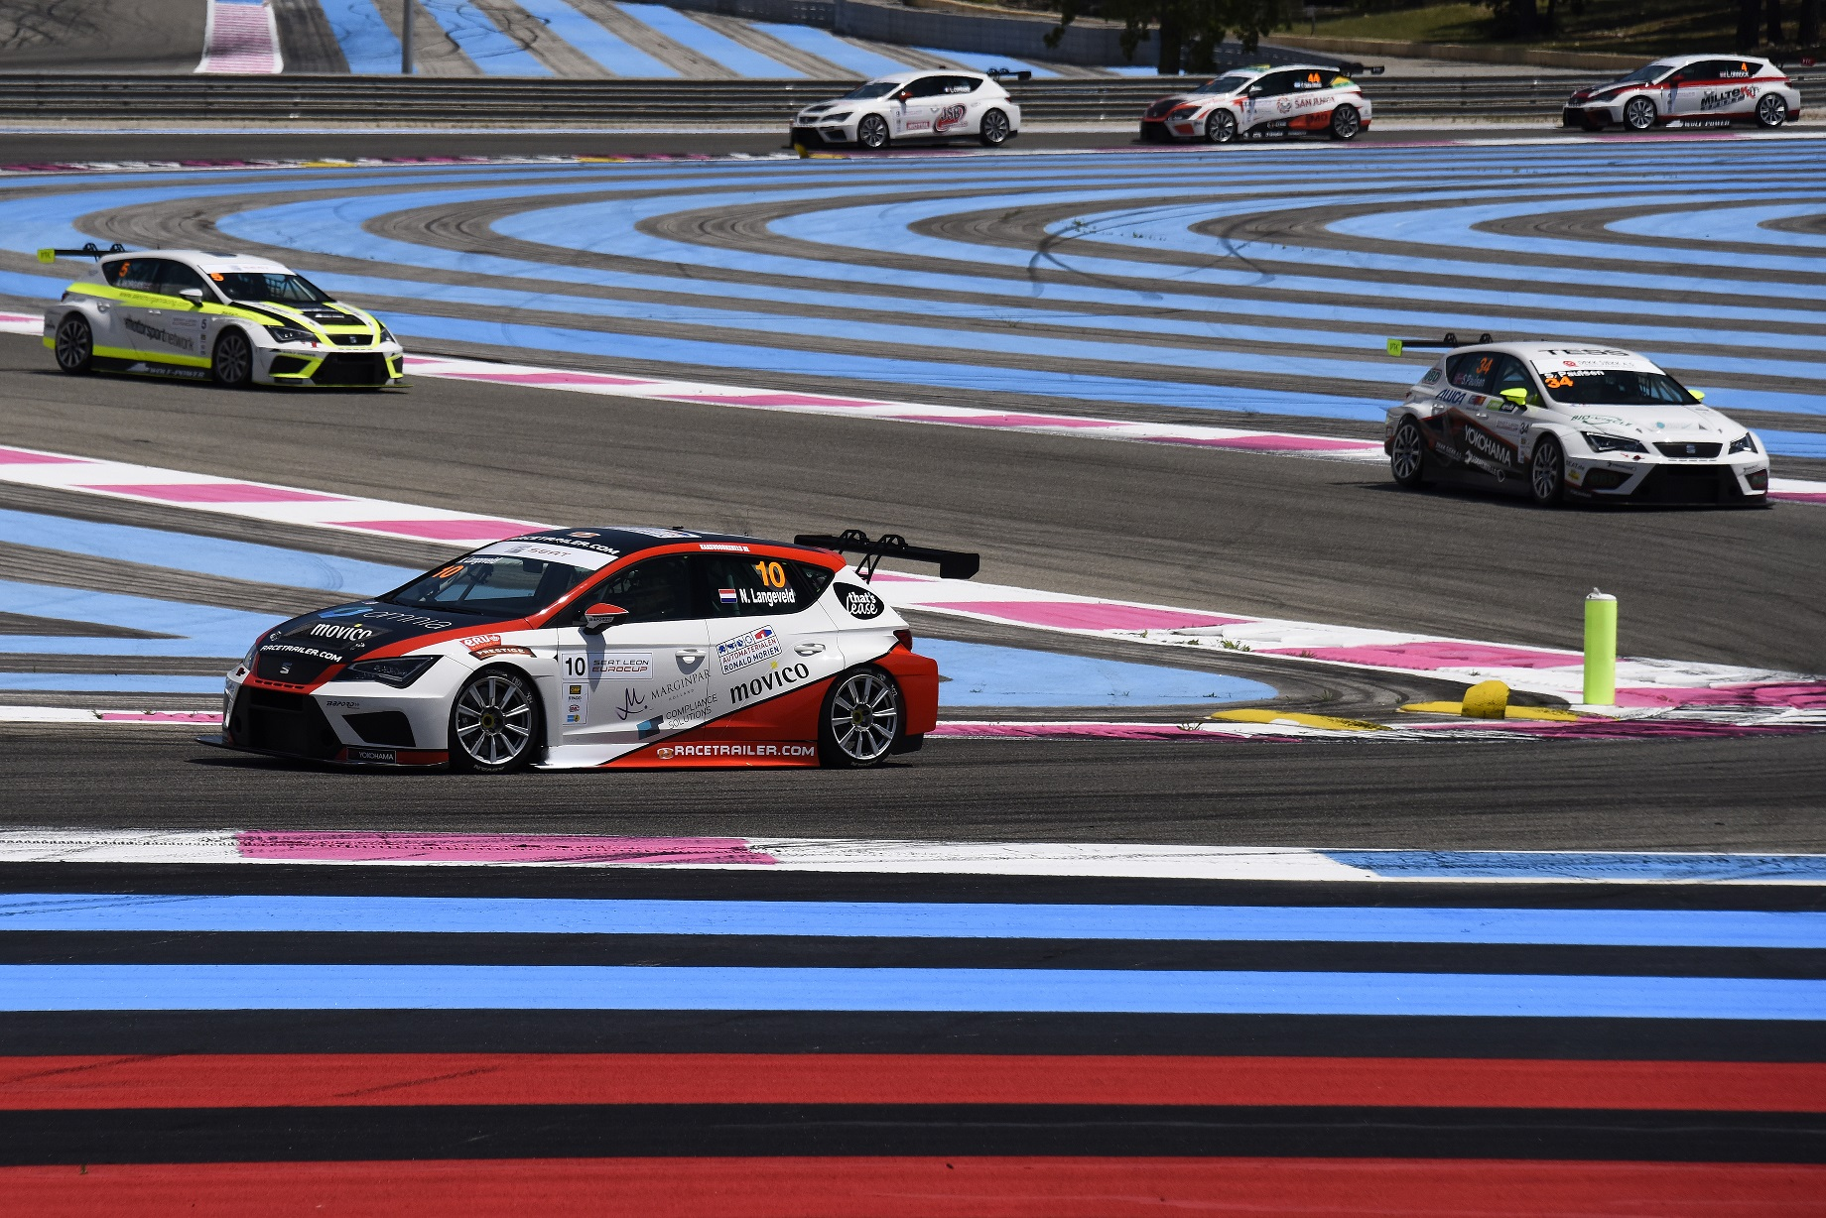
Flying Dutchman at Paul Ricard with SEAT LEON Eurocup

